PART 01 - IMAGE FILES

- Use appropriate file types for each image.
JPG is generally your best option for photos. It uses lossy compression, which means that some of an image’s data is lost when saved in this format. This data loss is undetectable to viewers in photos, but results in a smaller file size than most image file types.
PNG, use lossless compression. This means that when you save an image as a PNG, you don’t lose any data, and the resulting file size is larger than a JPG. If you need to have clear lines and crisp detail, PNG is the way to go. This is the best option for logos, screenshots, line art, and other detailed graphics.
GIF should only be used for small or simple graphics of less than 10×10 pixels, a color palette of 3 or fewer colors, and for animated images.
Once you’ve got your image sizes and formats right, you can make sure that the code you use to implement them is right, too. In particular, make sure to avoid empty image src codes. In HTML, the code for an image includes this: <img src=””>. When there’s no source in the quotation marks, the browser makes a request to the directory of the page or to the actual page itself. This can add unnecessary traffic to your servers and even corrupt user data.
- Use web font.
See: CSS sprites for Responsive Web Design ZDNet.html

- Resize images.
Don’t just upload an image that is 2000px wide and set the width parameter the size you want. This requires your page to load the full image, then adjust it to the appropriate size, slowing your page.

- Compressing the picture.
- You can make these kinds of changes in a premium tool like Photoshop, or a free program like Gimp. There are even in-browser tools like picresize.com.
- Use OptiPNG compresses PNG, GIF and other formats.
- Use compressor.io.

- Use adaptive images.
Adopt new image formats like WebP and JPeg XR.
WebP supported by Chrome and Opera. Jpeg XR supported by IE.
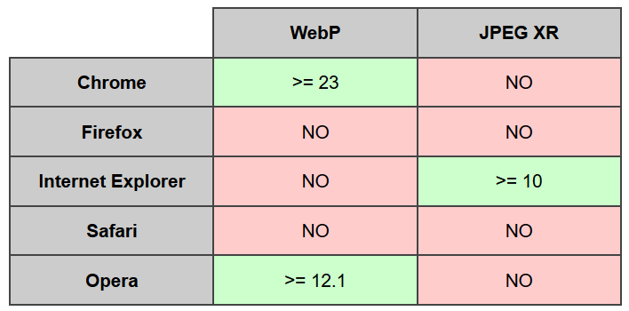

- Combine images into CSS sprites.
Sprites combine all background images on a page into one single image, which means all images appear when the main “sprite” loads. This reduces the chance of flickering images and a smoother experience for your users.
Use: https://cssspritestool.com/ https://www.toptal.com/developers/css/sprite-generator/
For responsive css use: https://responsive-css.spritegen.com/

- Prioritize above-the-fold content (lazy loading)
You can improve user experience by having your above the fold (top of the page) section load faster — even if the rest of the page takes a few seconds to load.
This is called lazy loading and is particularly helpful for pages with lots of content below the fold.
For example, let’s say you write a blog post that includes 20 photos. Normally, a user’s browser would need to download all of those images before displaying anything on the page.
With lazy loading, it can load the content within view first, then load all of those photos after.
This way, the user doesn’t have to wait to access the page, and the images will load as they come into view.

For detail process, see : 20 Ways to Speed Up Your Website – and Improve Conversion by 7%.html

PART 02 - stylesheet and javascript file

- Use one single stylesheet and javascript file instead of many small ones.
If you’re not sure how your CSS is currently set up, you can use this CSS delivery tool to find out. Enter your URL, and you’ll see a report with all of external your CSS files.
Once you’ve combine css file and update your HTML to reference this new file,, you can use PageSpeed Insights to make sure that you do not have any issues with render-blocking CSS.

- Keep your CSS files small.
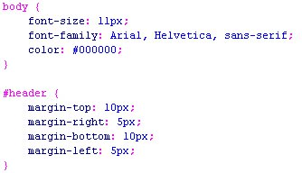

- Minification
“Minification does things like removing whitespace, removing comments, removing non-required semicolons, reducing hex code lengths…”Here are some minifying tools:
- (WordPress Plugin) BWP Minify: allows you to combine and minify your CSS and JavaScript files
- (WordPress Plugin) W3 Total Cache: This is one of the most popular performance plugins. In fact, I use it on Learn to Code With Me.
- WillPeavy: Free HTML, CSS, or JS minifier.
- CSS Minifier/Compressor
- https://javascript-minifier.com/

- Use asynchronous loading for CSS and JavaScript files
If it gets to a CSS or JavaScript file that is not asynchronous, it will stop loading until it has fully loaded that particular file. If that same file were asynchronous, the browser could continue loading other elements on the page at the same time.

- Defer JavaScript loading
Deferring a file means preventing it from loading until after other elements have loaded. If you defer larger files, like JavaScript, you ensure that the rest of your content can load without a delay.

- If you would like to keep them separate for better maintenance, you can bundle them into one request dynamically:
<?php
# File css.php
readfile("stylesheet1.css");
readfile("stylesheet2.css");
?>
you will have to set the header information manually in PHP like this:
# File css.php
header('Content-type: text/css');
# ...
Save this code as a file called something like css.php and reference it from your HTML:
<link rel="stylesheet" type="text/css" href="/css.php" />

PART 03 - File compression - Gzipping
“Gzipping finds all repetitive strings and replaces them with pointers to the first instance of that string.”
- Use GIDNetwork to run a compression audit.
Ii. Compressing files is one of the easiest ways to reduce load times, and today, enabling compression with Gzip is considered standard practice.
iv. This works well with CSS and HTML, because these files typically have repeated code and
v. Whitespace. According to Yahoo, this can reduce download time by about 70%.
vi. Use checkgzipcompression.com.cutestat.com to see if your site has Gzip enabled.
vii. If you have a static HTML site, however, you’ll need to enable Gzip in your .htaccess file. The exact code you need depends on your server but if your site runs on Apache, for example, it looks like this:
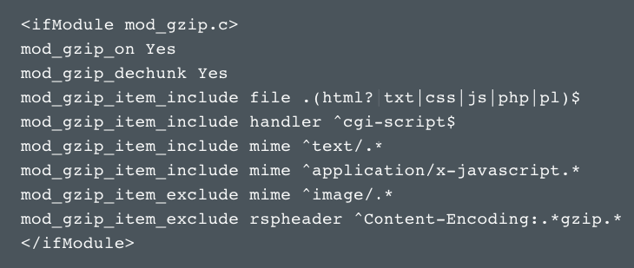

Gzipping is done at the server level: you must configure it to do it. Chris Coyier talks about it here.
Check web server of your webpage: https://sitereport.netcraft.com/
you will need to have two Apache modules loaded:
LoadModule headers_module modules/mod_headers.so
LoadModule deflate_module modules/mod_deflate.so
The following directives don't work in .htaccess. You need to place them in your servers config, i.e your virtual host container:
# Compress some text file types
AddOutputFilterByType DEFLATE text/html text/css text/xml application/x-javascript
# Deactivate compression for buggy browsers
BrowserMatch ^Mozilla/4 gzip-only-text/html
BrowserMatch ^Mozilla/4\.0[678] no-gzip
BrowserMatch \bMSIE !no-gzip !gzip-only-text/html
# Set header information for proxies
Header append Vary User-Agent
The first line says what file types should be compressed. Add the uncompressed file types you host on your server. It makes no sense to compress already compressed files like images or archives. Compressing these files again will only increase your server's load. The next three lines just exclude some know buggy browsers from the benefits of compression. The last line tells proxies not to deliver the same content to all user agents, because some of them just can't handle it.
The downside of mod_deflate is the CPU time consumption. You may have to tweak the compression level to meet your needs:
# n = 1..9 with 9 being the highest compression level. Standard is 6.
DeflateCompressionLevel n

PART 04 -Caching

- Enable PHP caching.
- servers config files and .htaccess
You need to have Apache's mod_expires on your server for this to work. If you have access to your servers config files, check if the following line is commented out in the load modules section:
LoadModule expires_module modules/mod_expires.so
In your .htaccess or preferably virtual host container insert something like this:
ExpiresActive On
ExpiresByType text/html "access plus 30 seconds"
ExpiresByType text/css "access plus 2 weeks"
ExpiresByType text/javascript "access plus 2 weeks"
ExpiresByType image/png "access plus 1 month"

If you’re not using WordPress, you can configure your site to cache at the server level. Digital Ocean has a handful of helpful caching tutorials.

====================================================================================
If you have a static HTML site, you can enable caching by in your .htaccess file.
You can add lines of code that tell browsers what to cache and how long to store it, which will look something like this:

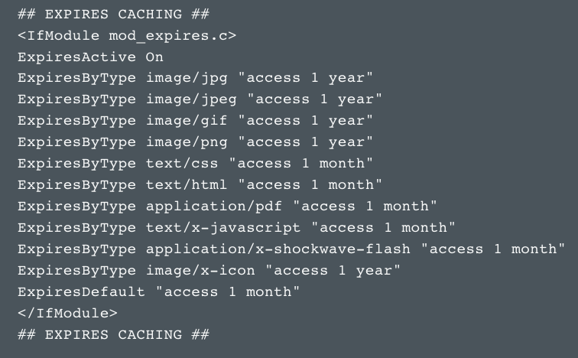

Configure the “expires headers”
For all types of cache, there is an expiration date in the file header which determines how long these files will be stored on the visitor’s computer and on the servers. The default is set to zero seconds, so everything expires right away. Images (jpg) are set to 1 week.
TIP: Increase the “expires header” for static files like images as high as you want. The expiration date for dynamic data that you update frequently should remain at zero seconds.
Check caching : https://www.giftofspeed.com/cache-checker/

PART 05 - CDN (Content Delivery Network)

- Use a CDN (Content Delivery Network).
With a CDN, you cache your site on a global network of servers. When a user’s browser requests files from your site, that request is routed to the closest server.

If you want to start using a CDN, your best options are MaxCDN and Cloudflare.
MaxCDN is a full CDN, meaning that it only offers CDN services. They have more data centers and focus solely on improving load times.
Cloudflare, on the other hand, combines CDN service with security and optimization features.
For detail process, see : 20 Ways to Speed Up Your Website – and Improve Conversion by 7%.html

Using Cloudflare in cynet:

PART 1 - Register in cloudflare.
step 1 : go to cynet cpanel, click "cloudflare" in software section.
step 2 : register (if you are new user) .
step 3 : fill in your domain, get the new Nameserver.

PART 2 - Changing the Nameserver.
step 1 : go to https://www.cynet.com.my/
step 2 : sign in at "CLIENT AREA"
step 3 : click "Domains" and "Manage Domain"
step 4 : click three dots beside seo2014, t hen click "manage Nameservers"
step 5 : change the Nameserver.

ns1.cynethost.com > eric.ns.cloudflare.com
ns2.cynethost.com > sima.ns.cloudflare.com

step 6 : use https://lookup.icann.org/lookup to check your Nameserver.

PART 3 - Caching.
step 1 : go to https://dash.cloudflare.com/
step 2 : click "seo2014.com" or other websites.
step 3 : click "caching" on the top icon.
step 4 : click "Custom Purge"
step 5 : key in the files you need to cach in the cloudflare server.
Note: caching in .htaccess first then only caching in cloudflare for secondary step.

PART 06 - OTHERS

- Use external hosting platforms.
Use external hosting platforms for some of your larger files. This is particularly valuable for videos.
host your video on a third-party service like YouTube, Vimeo, or Wistia. Then, embed the video on your site. This process saves space, results in faster load times, and is extremely easy to do.

**SAME for LARGE PHOTO

- Minimize time to first byte
Time to first byte, or TTFB, is the amount of time a browser has to wait before getting its first byte of data from the server. Google recommends a TTFB of less than 200 ms.
You can see how long this process takes for your site using either Chrome’s Developer Tools or a third-party tool.
In general, most issues with slow TTFB are caused by either network issues, dynamic content creation, web server configuration, and traffic.
Of these four factors, you have control over two: Dynamic content creation and server configuration.
You can reduce the time that this takes by enabling caching — which we’ll get to in a minute.
More details: 20 Ways to Speed Up Your Website – and Improve Conversion by 7%.html
- Enable HTTP keep-alive response headers.
HTTP requests are simple: they grab a single file, distribute and close. That said, this process is not always fast. Keep-alive allows the web browser and server to agree to use the same connection to grab and send multiple files. In other words, the server holds the connection open while a user is on the site instead of opening a new connection with every request, easing the load for the processor, network and memory.

- Reduce redirects
More details: 20 Ways to Speed Up Your Website – and Improve Conversion by 7%.html

- Reduce external scripts
You can identify all of the external scripts that are adding requests by reopening the network tab in Chrome’s Developer Tools.

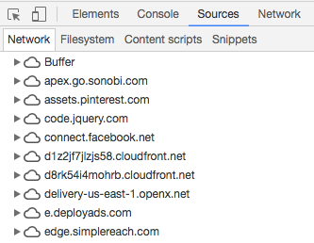

Apache fine tuning
Needs access to .htaccess or server config
If you have access to your servers configuration, there is some more settings you can play with. For one, disable host name lookups. It will safe time on every request. You will not have host names of clients available in CGI scripts and access_log, but there is better tools for that anyway in post processing of your log files. Preferably in your server config or on a directory level in your .htaccess turn it off like this:
HostnameLookups Off
In one last step, configure persistent connections in Apache's config. Persistent connections let the browsers request multiple files with one TCP connection, thus reducing overhead for TCP handshakes and speeding up requests a lot. These are the standard settings with Apache 2.2:
KeepAlive On
MaxKeepAliveRequests 100
KeepAliveTimeout 15
The standards are fine actually, but it's a good idea to experiment with these under your server's regular load conditions. MaxKeepAliveRequests is the maximum number of requests in one persistent connection. More is better, but bad spambots that request many pages at once may suck up all available connections if that number is too high.
KeepAliveTimeout is the timeout after which a persistent connection is dropped. The optimal value here depends on your server load and the clickyness of your web site. If visitors of your web site make many clicks in a short time, you can tweak that value to let one visitor always click within one persistent connection. Note that this is only advisable if your overall traffic is rather low. If you expect high peaks in traffic, don't set this value too high because you might end up having no connections left to serve new incoming requests.
- Use plugins sparingly (WP sites only)
More details: 9 Ways to Make Your Website Super Fast.html
More details: 20 Ways to Speed Up Your Website – and Improve Conversion by 7%.html

- Evaluate your plugins.
Plugins can bring new functionality and features to your website, but the more plugins your website has, the longer it takes to load. Poor or outdated plugins can slow down website performance dramatically, which could be fixed by removing plugins that duplicate functionality, are out of date or are no longer used.

- Monitor mobile page speed
using Google’s Test My Site tool to audit your own page speed. To get started, just enter your URL.

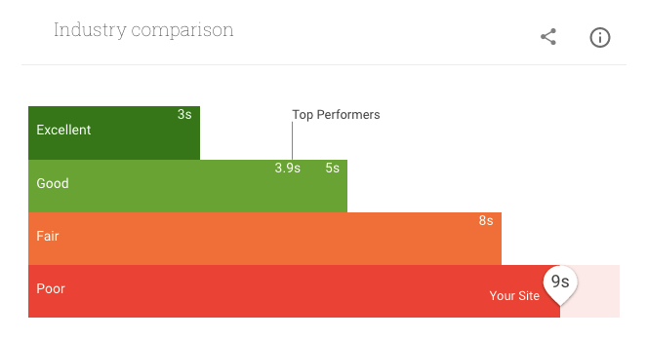

- DNS .
Switching to a faster DNS provider can speed up the process.
More details: 20 Ways to Speed Up Your Website – and Improve Conversion by 7%.html

